---Create a new table named marketing_campaign

CREATE TABLE marketing_campaign_staging(
campaign_id INTEGER PRIMARY KEY,
date DATE,
company TEXT,
campaign_type TEXT,
target_audience TEXT,
duration TEXT,
channel_used TEXT,
conversion_rate NUMERIC(5,2),
acquisition_cost TEXT,
roi NUMERIC(6,2),
location TEXT,
language TEXT,
clicks INTEGER,
impressions INTEGER,
engagement_score INTEGER,
customer_segment TEXT
);
DROP TABLE marketing_campaign;

---Run a check to see if table has been created
SELECT * FROM marketing_campaign_staging;

--import data into the staging table
--Perform data cleaning by ensuring data quality is achieved
--change the data type for acquisition cost to numeric

ALTER TABLE marketing_campaign_staging
ADD COLUMN acquisition_cost_clean NUMERIC(10,2);

UPDATE marketing_campaign_staging
SET acquisition_cost_clean =
REPLACE(REPLACE(acquisition_cost, '$', ''), ',', '')::NUMERIC;

--change data type for duration to integer
ALTER TABLE marketing_campaign_staging
ADD COLUMN duration_days INTEGER;

UPDATE marketing_campaign_staging
SET duration_days =
(REGEXP_MATCH(duration, '^\d+'))[1]::INTEGER;

--trim key categorical columns
UPDATE marketing_campaign_staging
SET company = TRIM(company),
campaign_type = TRIM(campaign_type),
target_audience = TRIM(target_audience),
channel_used = TRIM(channel_used),
location = TRIM(location),
language = TRIM(language),
customer_segment = TRIM(customer_segment);
---check for duplicates
SELECT campaign_id, COUNT(*)
FROM marketing_campaign_staging
GROUP BY campaign_id
HAVING COUNT(*) > 1;

--create the final clean table

CREATE TABLE marketing_campaign AS
SELECT
campaign_id,
date,
company,
campaign_type,
target_audience,
duration_days,
channel_used,
conversion_rate,
acquisition_cost_clean AS acquisition_cost,
roi,
location,
language,
clicks,
impressions,
engagement_score,
customer_segment
FROM marketing_campaign_staging;

ALTER TABLE marketing_campaign ADD PRIMARY KEY (campaign_id);

--run some checks to see if the table was properly cleaned.

SELECT COUNT(*) AS total_rows FROM marketing_campaign;

SELECT * FROM marketing_campaign;

--SQL ANALYSIS TO ADDRESS MARKETING RELATED QUESTIONS.

1.--FIND THE CAMPAIGN TYPE WITH THE HIGHEST IMPRESSIONS.
SELECT campaign_type,
SUM(impressions)AS total_impressions
FROM marketing_campaign
GROUP BY campaign_type
ORDER BY total_impressions DESC;

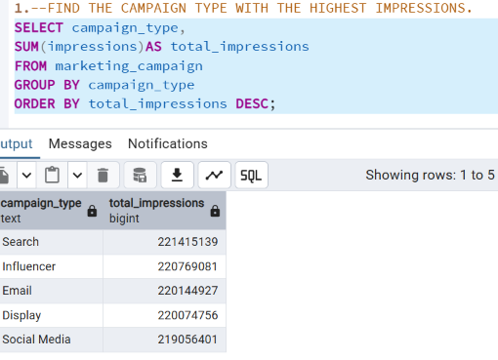

2.--WHAT COMPANY HAD THE HIGHEST ROI
SELECT campaign_id,company,roi
FROM marketing_campaign
ORDER BY roi DESC
LIMIT 1;
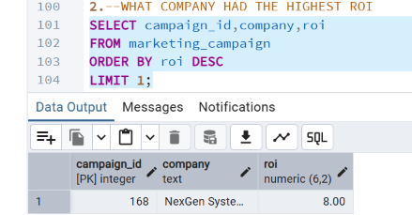

3--FIND THE AVERAGE ENGANGEMENT SCORE BY TARGET AUDIENCE
SELECT target_audience, AVG(engagement_score) AS avg_engagement_score
FROM marketing_campaign
GROUP BY target_audience
ORDER BY avg_engagement_score DESC;
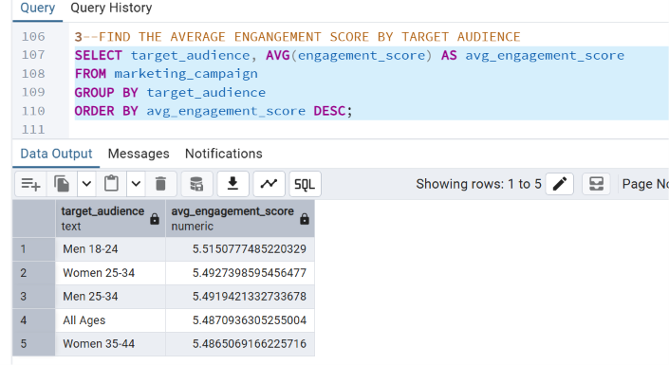

4---FIND THE MOST COST EFFECTIVE CAMPAIGN
SELECT campaign_type,
company,
(SUM(acquisition_cost)/NULLIF(SUM(clicks),0)) AS cost_per_conversion
FROM marketing_campaign
GROUP BY campaign_type,company
ORDER BY cost_per_conversion ASC
LIMIT 1;
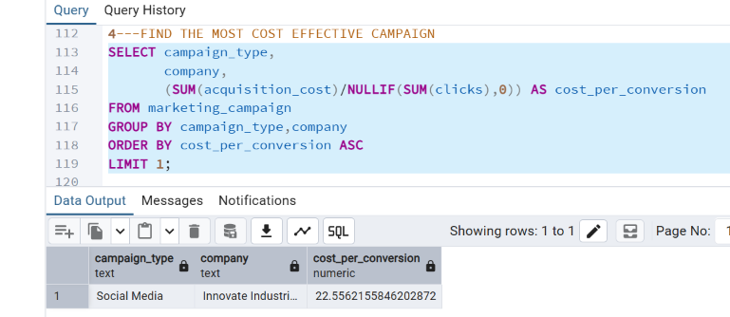

5--WHAT CHANNEL HAD THE HIGHEST CONVERSION
SELECT channel_used,
ROUND(SUM(clicks * conversion_rate/100),2) AS total_conversions
FROM marketing_campaign
GROUP BY channel_used
ORDER BY total_conversions DESC;
